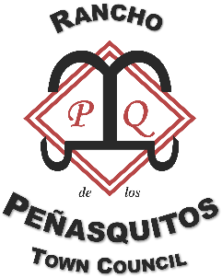
2025-2026 Board Candidate Bios

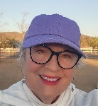
Kate Glenn D1 Adobe Bluffs Business Owner, Community Leader
Statement of qualifications
Current RPTC Board Member, President.

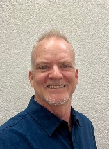
Erik Bratt D5 Park Village Brand Marketing & Communications Specialist
Statement of qualifications
I am a longtime PQ resident who has been involved in community sports and other activities for 20+ years. I recently oversaw the Entertainment Schedule at the 2025 PQ Fiesta, helping to create the biggest rock event in PQ's history with 11 total cover bands. It was a huge success. I vetted the bands, came up with the schedule, sent emails, helped setup the stage, and collaborated with key Fiesta stakeholders.
As a former journalist who turned marketing professional, I bring strong marketing and communications skills that can be very beneficial to the Town Council. I am a frequent volunteer at many community and city events. This includes being the Parade Line Finish manager at the San Diego Pride Parade for the last four years.
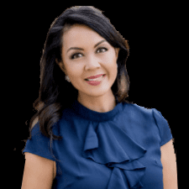
Jocelyn Lomahan D5 Park Village – Realtor, Community Advocate
Statement of qualifications
Current Board Member.
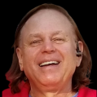
Jim Hogan D7 Sundance Cable TV
Statement of qualifications
Active volunteer in community
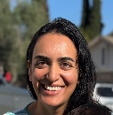
Sachi Patel D7 Sundance Physician, Democrat, Environmentalist
Statement of qualifications
I am a physician and a resident of Rancho Penasquitos. I would like to advocate for climate change and for small businesses.
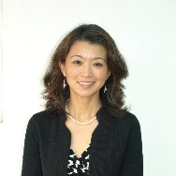
Chenyang Rickard D9 Torrey Highlands, 22 yrs
Mother, Attorney, Neighbor, Volunteer
Statement of qualifications
As a longtime resident of Rancho Peñasquitos, I care deeply about the well-being, diversity, and future of our community. I am a practicing estate planning attorney, a licensed real estate broker, and a proud board member of both the Alliance of Chinese Americans San Diego and the San Diego Chinese Attorneys Association. I have also volunteered with Meals on Wheels for over six years, serving our seniors with dedication and compassion.
My professional background gives me insight into the legal, housing, and policy issues that impact our neighborhoods, while my volunteer work reflects my commitment to service and community inclusion. My children were born and raised here, and I’ve witnessed firsthand how much we can accomplish when neighbors come together.
I’m running for the Rancho Peñasquitos Town Council because I believe in civic engagement, grassroots leadership, and empowering residents to take part in shaping our community’s future. If elected, I will bring thoughtful leadership, cross-cultural perspective, and a collaborative approach to ensure Rancho Peñasquitos remains a vibrant, inclusive, and connected place for all.

